University of Kentucky Equipment

Technology | Picture | Brief Description | Location | Variables | Dimensions
AfiLab (afimilk, Israel) | 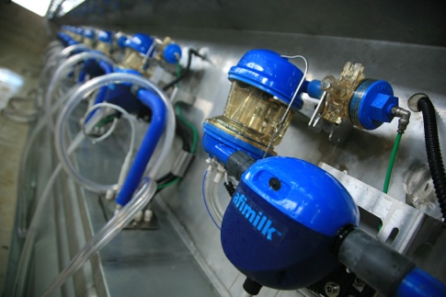 | An in-line monitor of milk quality. Gives an indication of components, and yield to give producers an idea of cow performance.  http://www.afimilk.com/sitefiles/1/2658/15296.asp | Parlor System | Fat Protein Lactose | N/A
Afiweigh™ (afimilk, Israel) | 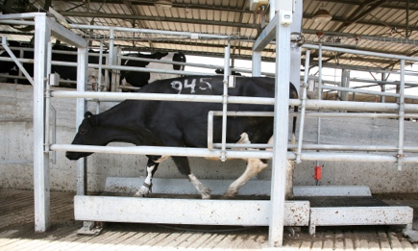 | The scale is placed in the exit of the parlor. Cows will automatically walk over it when returning from the parlor and it will automatically record their weight.  http://www.afimilk.com/sitefiles/1/2655/15293.asp | Parlor Exit | Cow Weight | N/A
Afimilk MPC milk meter (afimilk, Israel) | 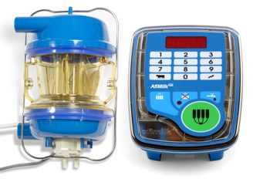 | The milk meter records yield, milk time, production rate, and conductivity as well as washing information | Parlor System | Milk time, Yield, Production Rate, Conductivity, Washing Information | N/A

Ambic Dairy Cow Mastitis Detector (Coburn Company, Whitewater WI) | 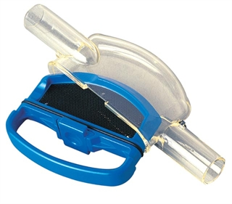 | A filter that allows for a reliable means of detecting clinical mastitis, this system detects the presence of mastitic clots without interfering with the smooth, rapid flow of milk away from the udder.  http://www.coburn.com/Coburn/ECommerce/Product-Detail.htm?catID=173&productID=AV2001 | Parlor | Presence of mastitic clots | N/A
HOBO RX3000 Remote Monitoring Station Data Logger | 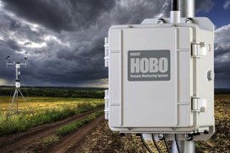 | Provides instant access to site-specific environmental data anywhere, anytime via the internet. The new station combines the flexibility and sensor quality of more expensive systems, an onboard LCD display, and the convenience of plug-and-play operation | Compost Bedded Pack Barn | N/A | N/A
HOBO 12-bit Temperature/Relative Humidity Smart Sensor | 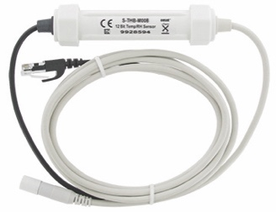 | Designed to work with all Onset data loggers that accept Smart Sensors. All sensor parameters are stored inside the Smart Sensor, which automatically communicates configuration data information to the logger without any programming, calibration, or extensive user setup. | Compost Bedded Pack Barn Pens | Temperature, Relative Humidity | Sensor Diameter- 10 mm  Sensor Length-35 mm  Cable Length- 8m

HOBO 12-Bit Temperature Smart Sensor | 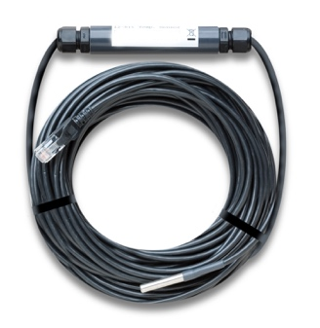 | The 12-bit Temperature Smart Sensor provides < ± 0.2° C total accuracy (< ±0.36° F) and resolution of < ± 0.03° C (< ±0.054° F) over the range of from 0° to 50° C (32° to 122° F). The full measurement range is -40° to 100° C (-40° to 212° F). A selectable measurement-averaging feature further improves accuracy. Reliable service is assured by a stainless steel sensor tip and robust cable rated for immersion in water up to 50° C for up to 1 year.  http://www.onsetcomp.com/products/sensors/s-tmb-m017 | Compost Bedded Pack Barn Water Troughs | Water Temp | Sensor Diameter- 5.1 mm  Sensor Length-33 mm  Cable Length- 17m
HOBO Contact Closure Pulse Input Adapter Sensor | 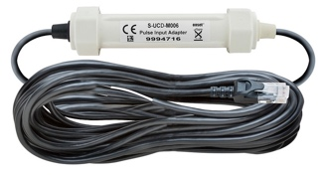 | Connects sensors with pulse outputs to data loggers with smart-sensor inputs. This smart sensor is compatible with contact closures, such as tipping-bucket rain gauges or reed switches with a maximum input frequency of 2 Hz (2 pulses per second), and records the number of pulses that happen over a period of time. This device groups together or bins the number of pulses according to the time period they occurred in.  http://www.onsetcomp.com/products/sensors/s-ucd-m006 | Compost Bedded Pack Barn Water Troughs | Flow Rate | Sensor Diameter- .095 cm  Sensor Length-17 cm  Cable Length- 6 m
No-lead Water Flow Meter Sensor | 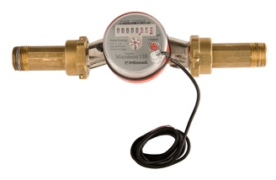 | Measure cold and hot water flow rates with this compact, affordable water meter | Compost Bedded Pack Barn Utility Room | Flow Rate | N/A

Cow Manager Sensor  (Cow Manager BV, Harmelen, the Netherlands) |  | 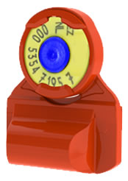 | An ear tag monitoring cattle head movement, feeding behavior, rumination, and temperature as general health, digestive health and estrus.  www.cowmanager.com | Ear | Rumination time, feeding time, ear skin temperature, and activity
BellaAg Temperature Bolus  (Bella Ag Systems, Loveland CO) |  | 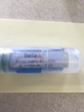 | An orally administered reticulorumen temperature bolus that allows a producer to monitor health and estrus in cattle through changes in temperature.  BellaAg Temperature Bolus  http://www.bellaag.com/ | Reticulorumen | Reticulorumen Temperature
MooMonitor+  (Dairy Master, Kerry, Ireland)) |  |  | A neck based collar system that monitors activity, rumination time, feeding time, and inactivity to predict health and estrus behavior.  http://moomonitor.dairymaster.com/ | Neck | Neck Activity
Nedap COWControl  (Nedap Parallelweg, The Netherlands) |  | 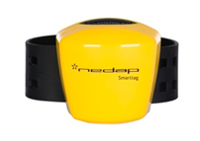 | A leg mounted technology that cow behavior in order to predict health and estrus events.  http://en.nedap-livestockmanagement.com/solutions/cows-and-cow-management/nedap-cowcontrol/ | Front Leg | Lying time, Standing time, Walking time, steps, and standup count (locomotion).
Nedap COWControl  (Nedap Parallelweg, The Netherlands) |  | 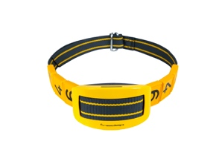 | A neck mounted technology that monitors cow behavior in order to predict health and estrus events and locates the animal (in the barn).  http://en.nedap-livestockmanagement.com/solutions/cows-and-cow-management/nedap-cowcontrol/ | Neck | Eating time, rumination, inactive behaviour, other active behaviour and cow positioning
MooCall  (MooCall Ltd, Dublin, Ireland) |  | 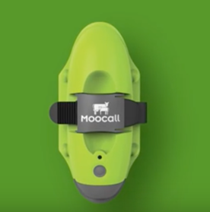 | A tail mounted sensor that measures tail movement pattern triggered by labor contractions for calving detection. When they reach a certain level of intensity over a period of time it then sends an SMS text alert directly to your cell phone. | Tail | Tail movement
Fresh Cow Manager  (Fresh Cow Manager, Boulder, CO) |  | 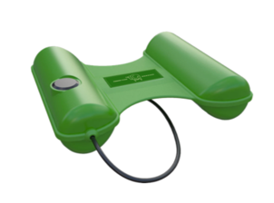 | A device that is attached to the rump and tail of the and using a gentle pain-free vibration of the tail the first 3 weeks post freshening. This sends signals to the brain that trigger increased activity. | Rump and Tail | N/A
 | AFIActII Pedometer (afimilk®, Afikim, Israel) | 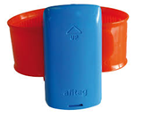 | A leg pedometer that calculates deviations of activity, standing and lying time, rest time.  http://www.afimilk.com/products/cow-monitoring/afiact-ii-leading-leg-tag-fertility-management-system | Right Rear Leg | Lying time and steps
 | Polar RS800CX (Polar Electro, Oy, Finland) | 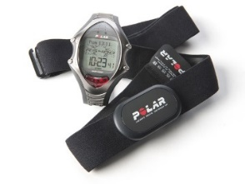 | A heart rate monitor that is placed around the heart girth of cows during visual observation. | Heart Girth | Heart Rate  Time | Weight:22g  Dimensions:2.1”x 0.87”x0.3”
 | SmartBow (Smartbow, GmbH, Jutogasse, Austria) | 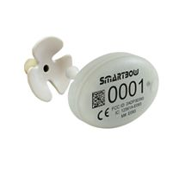 | The SMARTBOW Eartag records the activity of the animal, detects heat and changes in rumination behavior and locates the postion of animals in real-time. The system can be used in indoor and outdoor area.  www.smartbow.at/en | Ear | Position and movement | Weight: 34.0 g  Length: 5.20 cm  Height: 1.7 cm  Width: 3.6 cm
 | Track-a-Cow (ENGS, Hampshire, UK) | 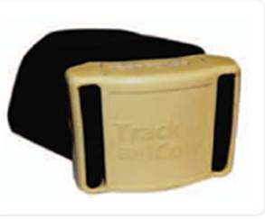 | A technology monitoring cow activity and lying and standing behavior as predictors of health and estrus. Additionally, this technology monitors feeding behavior in order to detect digestive health.  http://www.trackacow.co.uk/index.htm | Right Front Leg | Lying Time and Time at Feed Bunk | Weight: 0.18 lbs.  Width: 2.625 in.  Height: 1.875 in.  Depth: 1 in.
 | Centrifuge | 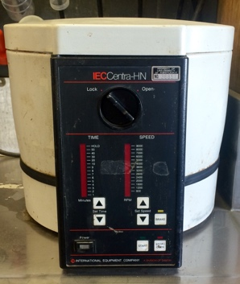 | used for spinning blood samples to collect plasma or serum | Classroom | N/A | N/A
 | Colostrometer | 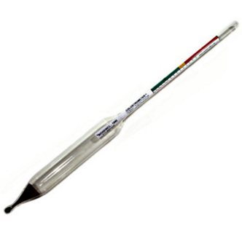 | Field method for immediate determination of colostrum quality | Classroom | Colostrum Immunoglobulins | N/A
 | Metricheck (VetENT, New Zealand) | 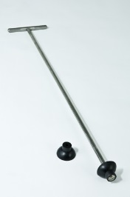 | Used to scoop discharge to be examined for endometritis  http://www.vetent.co.nz/dairy-disease-management/metricheck.html | Classroom | Uterine Discharge | N/A
 | Ultrasound | 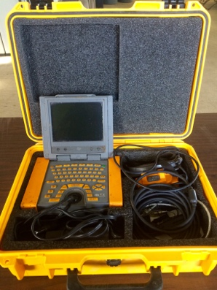 | used in pregnancy checking to determine age, sex, and location of fetus | Classroom | Pregnancy | N/A
 | Koster Dryer | 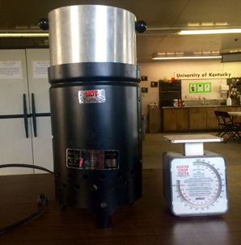 | portable electric dryer used to determine percentage of dry matter and moisture content of dry grain, high moisture grain, hay, silage, and other materials | Equipment Room | Dry Matter Moisture Content | N/A
 | pH meter | 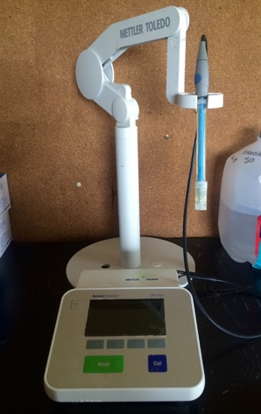 | Scientific instrument that measures the hydrogen ion concentration in a solution indicating acidity or alkalinity | Equipment Room | pH | N/A
 | Digital Thermometer | 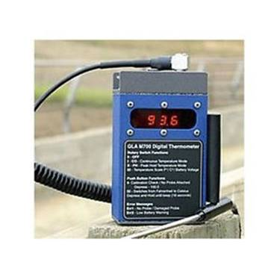 | Rechargable, digital thermometer used to take vaginal or rectal temperature | Equipment Room | Vaginal/Rectal Temperature | N/A
 | Rovimix Beta-Carotene Tester | 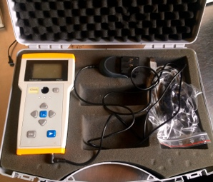 | tests beta carotene in either blood or milk samples. | Equipment Room | Beta carotene | N/A
 | AgriNIR Analyzer (Dinamica Generale®, Italy) | 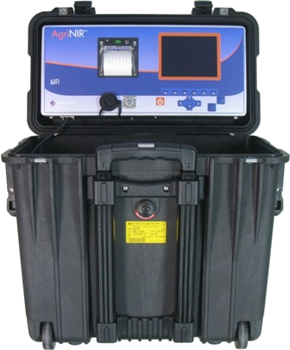 | A portable analyzer for forages and grains to measure a sample's DM, Starch, CP, CF, ADF, NDF, and Ash | Equipment Room | DM, Starch, CP, CF, ADF, NDF, and Ash | N/A
 | e Pro Check 2.0 (Frim Tec, Germany) | 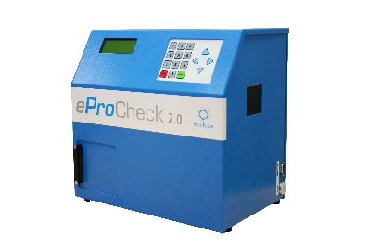 | To determine the immune parameters in the raw milk directly himself using this automatic analysis device to measure haptoglobin in milk | Equipment Room | Haptoglobin | N/A
 | Pain Test FPX 50 Algometer (Wagner instruments, Geenwich, CT) | 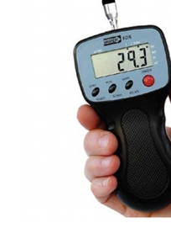 | Used to evaluate lesions while hooves are under restraint. The Algometer will be applied to lesion to determine level of pain.  http://www.wagnerinstruments.com/wagpdfs/fpx.pdf | Equipment Room | Kilograms of force causing the hoof to withdraw from the algometer | N/A
 | Q-Dry® (Q-Dry®, Germany) | 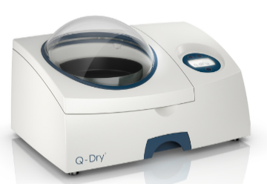 | Analyzes the dry matter content in animal feed stuffs. The Q-Dry automatically dries feed stuff samples by using an induction heating system.  http://q-dry.de/en/q-dry/ | Equipment Room | Feed Dry Matter Content | N/A
 | Q-Scout (Advanced Animal Diagnostics, Research Triangle Park, NC) | 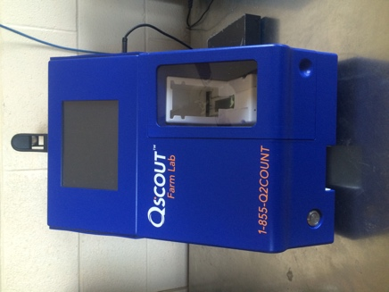 | An on farm, portable diagnostic analyzer, designed to provide producers with result in minutes. Q scout test accurately detect subclinical mastitis and individual quarters long before symptoms occur by analyzing ratios of white blood cell types that fight infection.  http://advancedanimaldiagnostics.com/ | Equipment Room | Milk leukocyte count (not attached to cow; milk test) | N/A
 | Infrared Thermography Camera (Flir, Boston, MA) | 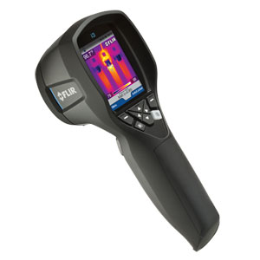 | Uses infrared thermography for early detection of lesions in cow’s hooves | Used in the parlor as a hand held device, stored in equipment room | Infrared Thermography | N/A
 | Bentley Combi | 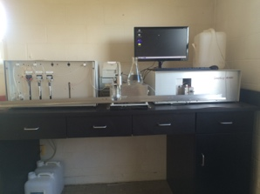 | The Bentley represents state-of-the-art technology for automated milk analysis for up to 600 samples per hour. The Bentley provides an accurate measurements the somatic cell count of milk samples while simultaneously measures the milk composition including fat, protein, lactose, and solid. | Bentley Lab | Fat, Protein, Lactose solid | N/A

